**Written Analysis of Results**

Purpose of Analysis

In my opinion the purpose of this challenge was to make codes to generate different analysis for stock markets between the year 2017 and 2018. I also believe this challenge’s purpose was to see the differences or speed executions between the original code and refactored code. This would help you in the near future while using VBA to pick the right script for different analysis to be more efficient and effective.

Results

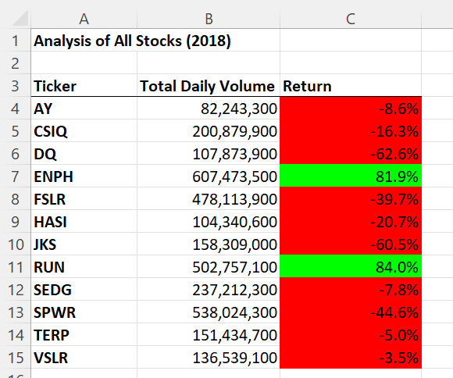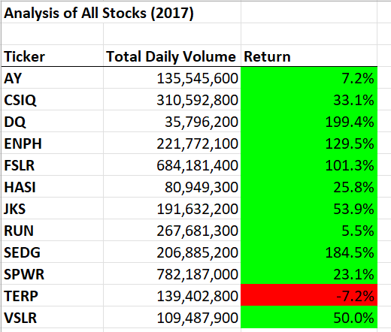

As you can clearly see there is a huge difference between the stock performances from the years 2017-2018. Just by looking at 2018 stocks you can see the first 3 stocks AY, CSIQ, DQ went downwards in performances. AY went down -8%, CSIQ went down -16% and DQ went down almost -63%. You can easily tell that 2018 year went downhill by the red font, as only 2 stocks went upwards which are ENPH (82%) and RUN (84%). Next analysis is going to be on the execution times between the original script and refactored script. Here are 2 images of the scripts. 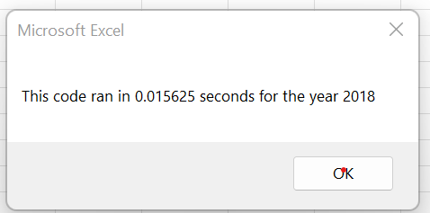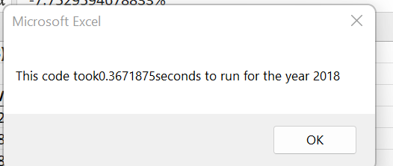

With a quick glance you can tell that there is a time difference. The one above which is 0.015625 seconds that is the refactored code. The under 0.3671875 is the original. So clearly the refactored version is quicker to get the analysis of the stock market.

Summary

The advantage of refactoring code is that it executes the program faster, helps finds bugs, improves the design of the program. The disadvantage of refactoring code is that it is very time consuming, and you can get lost very easily. These pros and cons apply to refactoring the original VBA script because while I was doing this challenge I got lost multiple times while making the script and I spent hours trying to figure out what mistake I made but once I got the script right my table (All Stocks Analysis) executed the analysis faster.